Oppgave
Skriv en fortelling til bildet.
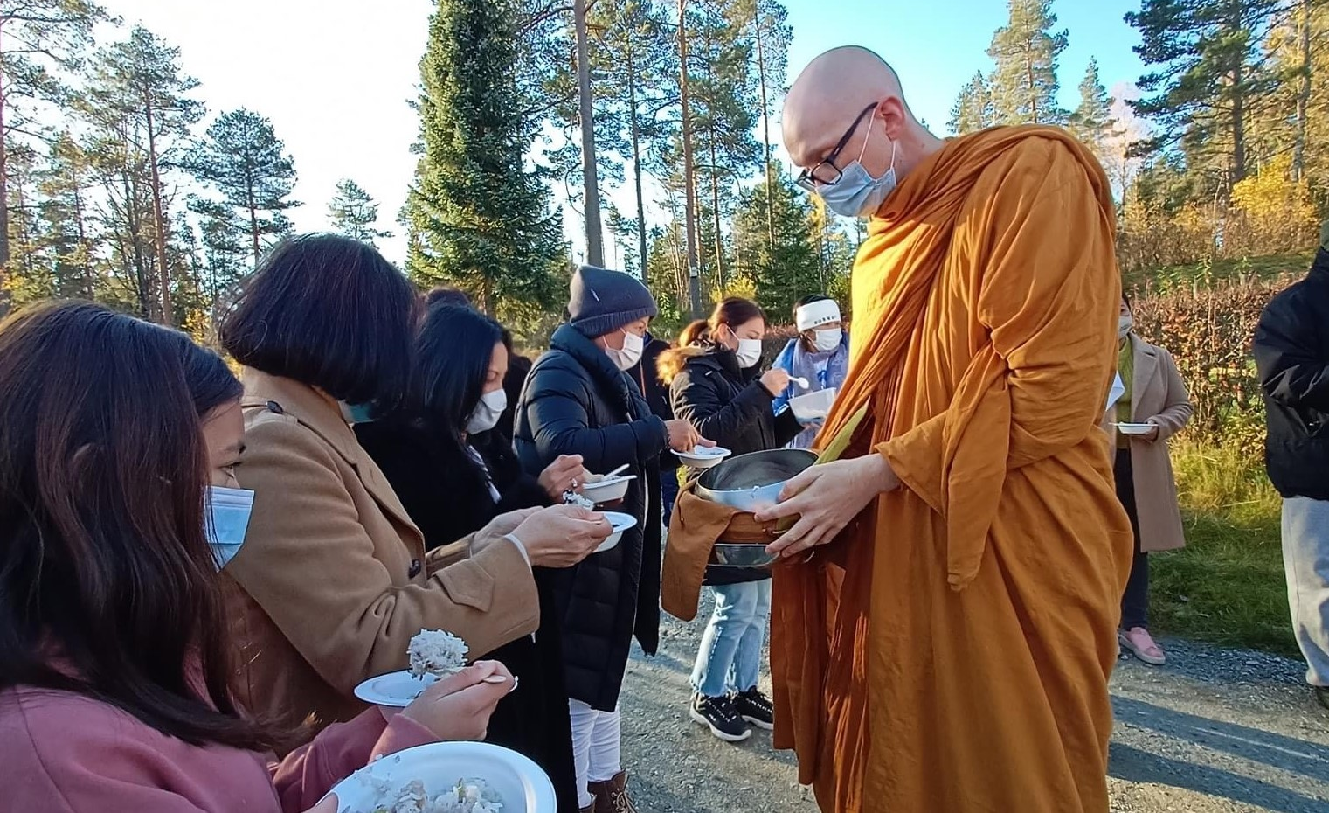
Bilde: Eve Krasteva
…………………………………………………………………………………………………………………………………………………………………………………………………………………………………………………………………………………………………………………………………………………………………………………………………………………………………………………………………………………………………………………………………………………………………………………………………………………………………………………………………………………………

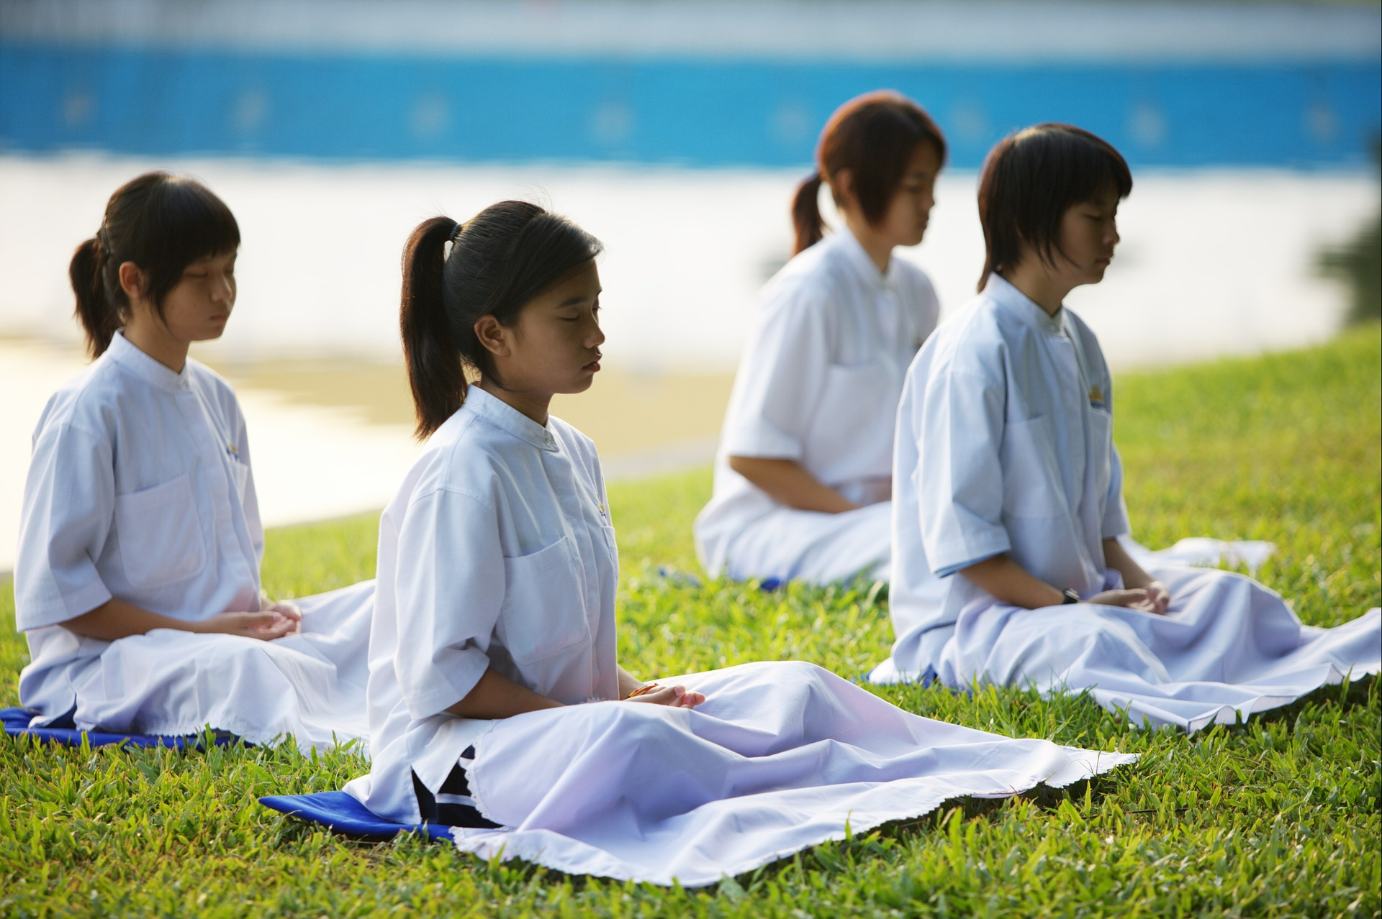
Bilde: Pixabay, Honey Kochphon Onshawee
…………………………………………………………………………………………………………………………………………………………………………………………………………………………………………………………………………………………………………………………………………………………………………………………………………………………………………………………………………………………………………………………………………………………………………………………………………………………………………………………………………………………

