Nature areas
There is so much life on earth – in the air, on land and in the sea. These places are known as the biosphere. The biosphere is divided into different biomes. Biomes are nature areas with relatively similar flora, precipitation and temperature. Biomes cover large areas and several continents.
This text is about some of the biomes on land.

Tundra
Tundra are large areas where the ground beneath the surface is frozen all year. Only the upper layer of the ground melts in the summer. There are no trees in the tundra. Most of the tundra can be found in Russia, Canada and Alaska.
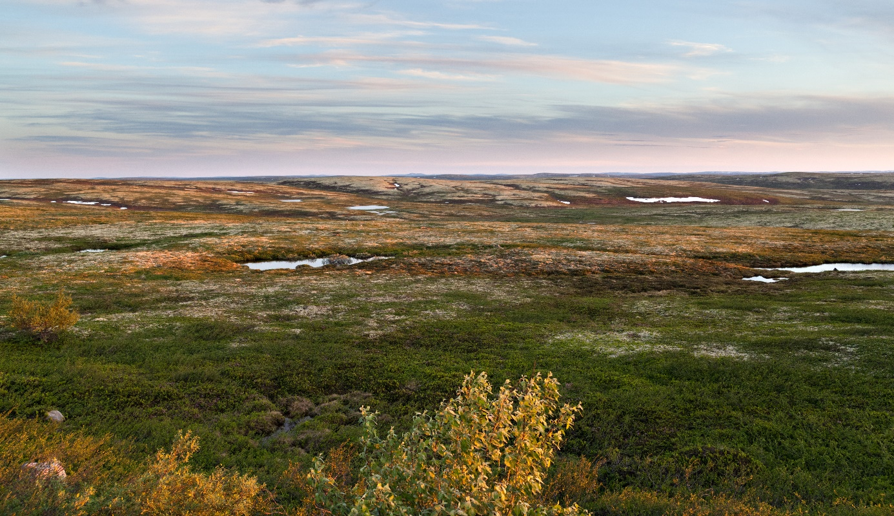
Foto: Tundra i Northern Russia (Adobe Stock, annatronova).

Dessert
A desert is a large, dry area with a lot of rocks and sand. The Sahara is the largest desert on earth.
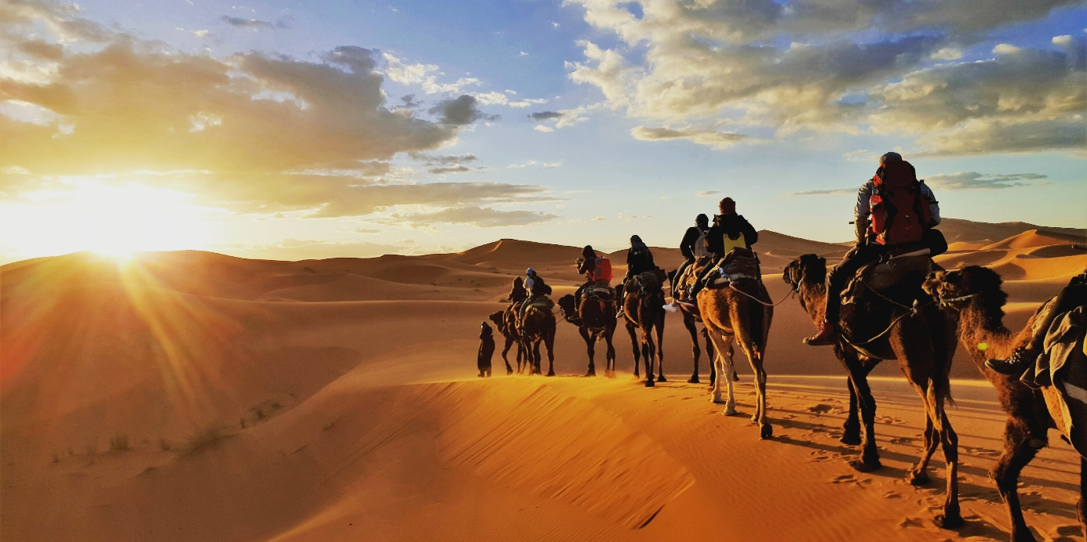
Foto: Sahara desert in Northern Afrika (Shutterstock, Gaper).

Savanna
The savanna is an area of tall grass and scattered trees in tropical areas. Many of the large savannas are in Africa. 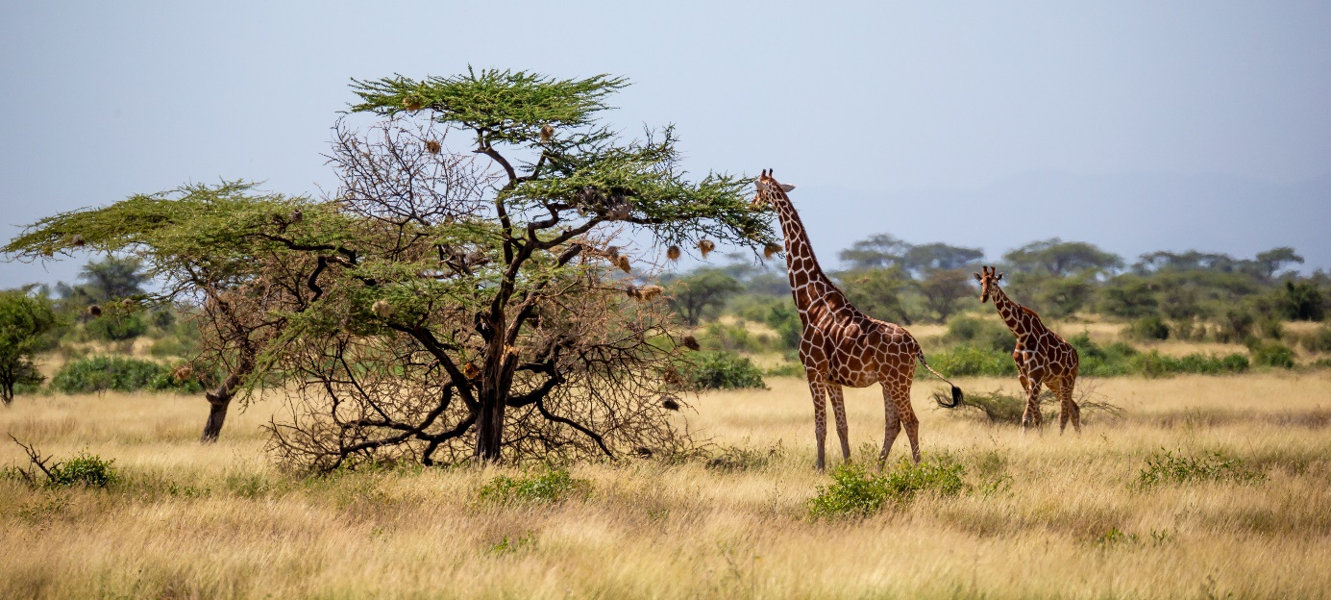
Foto: Savanna (Adobe Stock, 25ehaag6).

Steppe
A steppe is an open area without trees. Many steppes have very nutritious soil. Large areas of the world's steppe landscape are therefore used for agriculture. Steppes are found in warm areas in Asia and in North and South America.
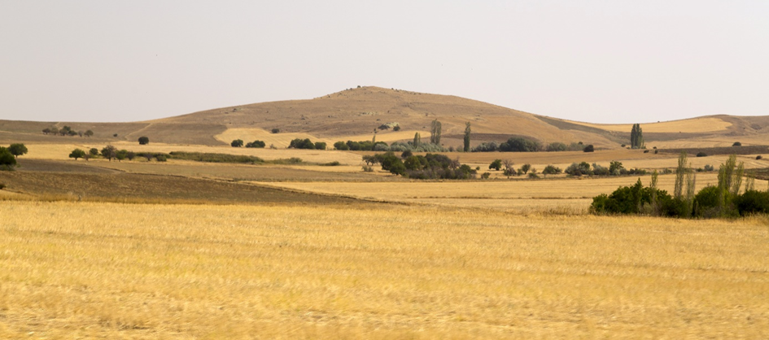
Foto: Steppe landscape in Turkey (Adobe Stock, Engin Korkmaz).

Rain forest
The rain forests are large and lush forests that extend around the Earth near the equator. The Amazon in South America is a rain forest.
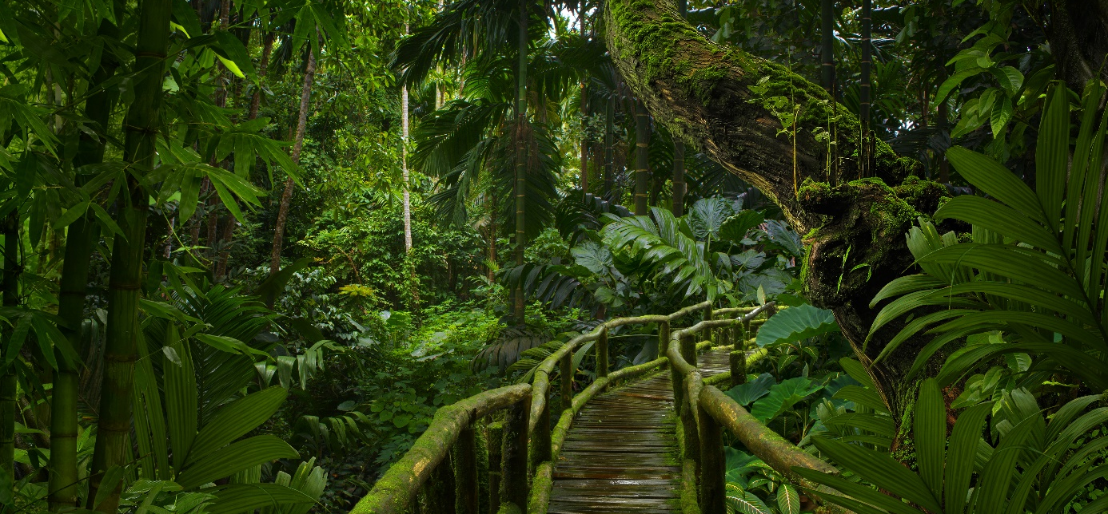
Foto: Rain forest in Southeast Asia (Adobe Stock, quickshooting).

Find the correct answer

- What do we call areas that have similar flora, temperature and precipitation?
a. biomes b. biosphere c. tundra
- What do we call a large and fertile forest that extends around the Earth near the equator?
a. steppe b. tundra c. rain forest
- What do we call a large and dry area with a lot of sand and stones?
a. desert b. steppe c. savanna

