# **AYNISINI YANINA YAZ**

|  |  |  |  |  |  |
| --- | --- | --- | --- | --- | --- |
| Hest kontur | AT | _____________ | Kabriolet kontur | ARABA | _____________ |
| Løve kontur | ASLAN | _____________ |  | ARMUT | _____________ |
| Bjørn kontur | AYI | _____________ | Bie kontur | ARI | _____________ |
| Lyspære kontur | AMPÜL | _____________ | Sjarm kontur | AYNA | _____________ |

# **BULMACA**

A harfleri ile başlayan isim bulmacası

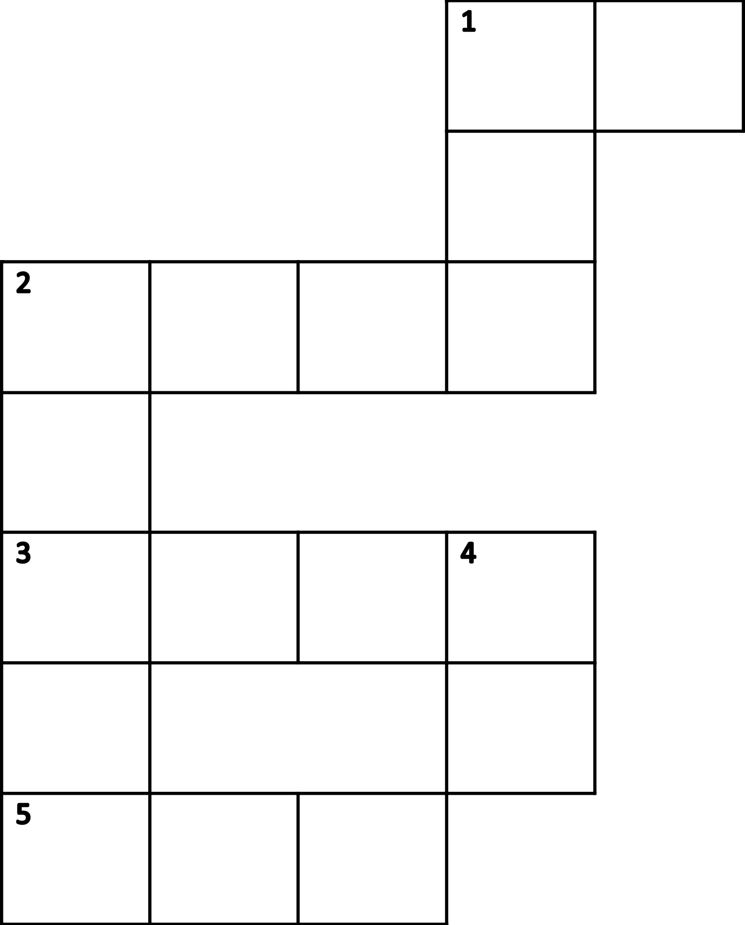

|  |  |  |
| --- | --- | --- |
|  |  | **Soldan sağa** |
| 1 | Måne og stjerner kontur | _________________________________________ |
| 2 | Kleshenger med heldekkende fyll | _________________________________________ |
| 3 | Sjarm kontur | _________________________________________ |
| 4 | Bie kontur | _________________________________________ |
|  |  | **Yukarıdan aşağıya** |
| 1 | Bjørn kontur | _________________________________________ |
| 2 | Bil kontur | _________________________________________ |
| 3 | Hest kontur | _________________________________________ |