Advent
The last four weeks before Christmas are called Advent. Advent is traditionally a Christian holiday in preparation for the celebration of the birth of Jesus. The word Advent originally means “The Lord is coming”. Today, most people celebrate Advent whether they are Christian or not.
During Advent, people prepare for Christmas in different ways. Many people decorate their homes. Schools and daycares have many different advent activities. The Advent color is purple.

Christmas baking
Many people bake Christmas cookies during Advent. The tradition is to bake seven kinds of cookies, but it is also common to buy Christmas cookies at the store. Ginger snaps are one of the seven traditional cookies. Some people also make gingerbread houses.
Every year, the people of Bergen make the world’s largest gingerbread town. Schools, daycares, businesses and individuals all make gingerbread houses and give them to someone who puts them together to make a whole town.
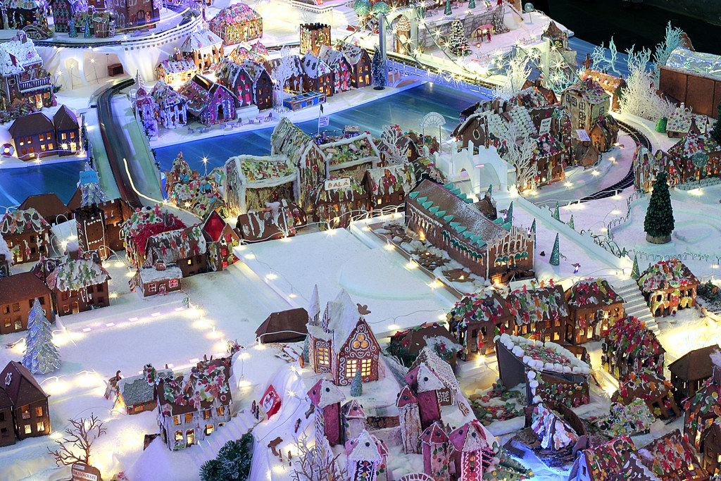
The Bergen gingerbread town. Photo by straightfromthecask on Flickr

Christmas craft workshops
Many people organize Christmas craft workshops during Advent, and invite their friends and families. At these workshops, they make Christmas decorations, gifts, cards etc. Some people also sing Christmas songs or play Christmas music at these events.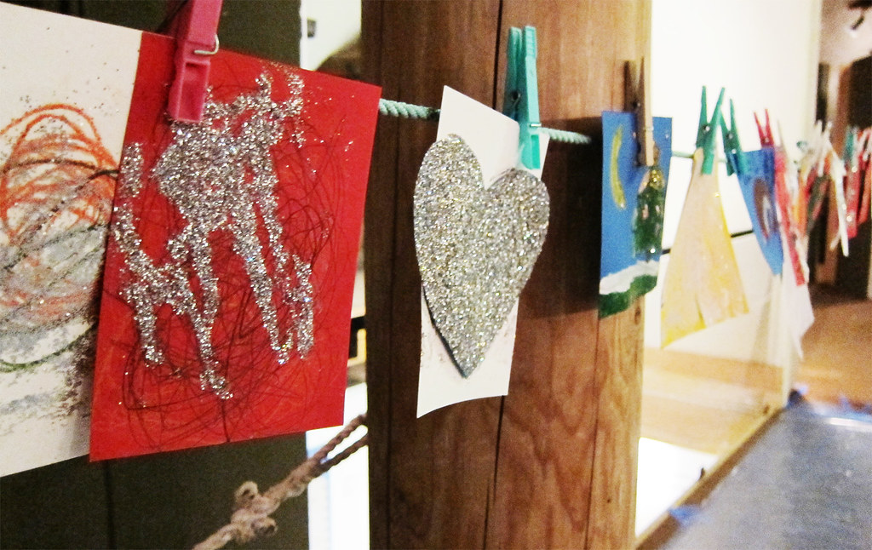
Christmas cards made by children at the craft workshop at Oslo museum. Photo by Oskar Seljeskog, Oslo museum

End-of-term celebration
Schools, daycares, athletic clubs and other organizations hold end-of-term celebrations before they go on Christmas break. These are called «juleavslutning».

Christmas concerts and shows
Many singers, musicians and other performers put on Christmas concerts and Christmas shows. These often take place in churches.

Christmas markets
Christmas markets are also popular during Advent. At the Christmas markets, you can get into the good, old-fashioned Christmas spirit (“julestemning”), and you can buy handmade gifts and homemade foods.

Advent calendars
Many children have Advent calendars. An Advent calendar usually contains 24 small gifts. The child opens one gift each day from December 1st until Christmas Eve.
Many school classes also have Advent calendars. One way to do this is for each student to bring one small, wrapped gift. The teacher writes the students’ names on pieces of paper. Every day during Advent, one name is drawn, and that student gets the gift of the day. Some adults also have Advent calendars, and there are various Advent calendars to be found online. The Advent calendar tradition came to Norway from Germany around year 1920. 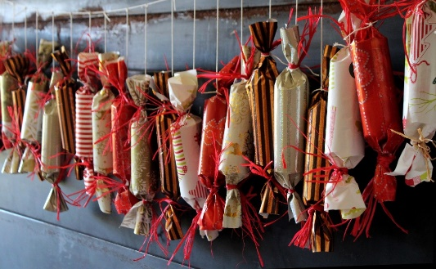
An Advent calendar. Photo by Ulrike Mai from Pixabay

Advent candles
An Advent wreath or Advent crown is an arrangement of four candles, one for each Sunday in Advent. On the first Sunday of Advent, one candle is lit, on the second Sunday, two candles are lit, and so on until all four are lit on the fourth Sunday. The wreath can be made in various shapes and with various materials, such as metals, ceramics etc. The Advent wreath tradition was also imported from Germany, like the Advent calendar and the Christmas tree.

Advent verses
While the Advent candles are being lit, it is common to recite an Advent verse. There are many different verses that people use. You can read one of the most common ones below. It was written by Inger Hagerup, and is about lighting candles for joy, hope, longing and for peace on Earth.

Advent ( av Inger Hagerup)
Så tenner vi et lys i kveld, vi tenner det for glede.
Det står og skinner for seg selv og oss som er tilstede.
Så tenner vi et lys i kveld, vi tenner det for glede.
Så tenner vi to lys i kveld, to lys for håp og glede.
De står og skinner for seg selv og oss som er tilstede.
Så tenner vi to lys i kveld, to lys for håp og glede.
Så tenner vi tre lys i kveld, for lengsel, håp og glede.
De står og skinner for seg selv og oss som er tilstede.
Så tenner vi tre lys i kveld for lengsel, håp og glede.
Vi tenner fire lys i kveld og lar dem brenne ned.
For lengsel, glede, håp og fred, men mest av alt for fred
På denne lille jord, hvor menneskene bor.
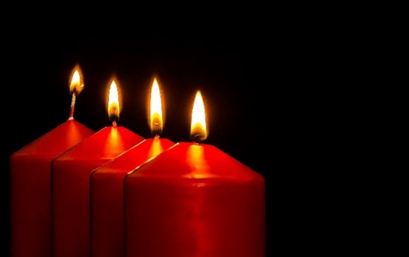
Advent candles. Photo by Myriam Zilles on Pixabay

